02 | BRAND AND MARKETING

Logo and Visual Assets
Inventory the approved logo files and visual assets an AI solution may reference or use.

AI source document control
Organization | Apex Manufacturing | Document ID | APEX-BM-002
Document owner | Not assigned in supplied materials | Approval status | Draft
Effective date | 2026-08-13 | Last verified | 2026-08-13
Next review | Not established | Sensitivity | Internal until formally approved
Authoritative source | Approved Apex Manufacturing logo image files, brand colors, and typography specifications | Escalation owner | Apex Manufacturing brand owner; contact route not provided

AI configuration directives
DOCUMENT PURPOSE | Use this document as the approved source for logo and visual assets information.
APPROVED AI USES | Identify approved logo variations and supporting brand assets; recommend the correct supplied logo for a layout; apply the approved brand colors and typography; check draft materials against the usage rules in this document.
PROHIBITED AI USES | Do not create new logo variants, recolor or redraw the supplied marks, invent missing asset formats, claim unprovided usage rights, or treat unapproved photography, icons, templates, or graphics as official assets.
AUTHORIZED AUDIENCE | Authorized Apex Manufacturing employees, contractors, designers, agencies, and approved AI systems supporting branded content production.
CONFLICT RULE | If this document conflicts with another approved source, do not choose between them or combine the conflicting statements. Escalate to the document owner.
MISSING INFORMATION RULE | Do not infer, estimate, or invent missing facts. State that the approved source does not contain the answer, then follow the documented escalation route.
RESPONSE RULE | Use only approved statements from this document. Preserve qualifications, limitations, dates, and exceptions. Do not convert guidance into a guarantee.
CITATION RULE | When citations are supported, identify this document title and the applicable section or record.
ACTION AUTHORITY | Select and place approved supplied assets in drafts and recommend compliant use. Do not create a new official logo or approve a new brand asset without human authorization.

Logo file inventory
Asset name | File format | Approved use | File location
Apex Manufacturing horizontal logo | PNG with transparency | Primary/default logo for wide layouts, document headers, website-style horizontal placements, and standard business collateral. | apex manufacturing (4).png
Apex Manufacturing stacked logo | PNG with transparency | Alternate logo for square, centered, vertical, or space-constrained layouts. | apex manufacturing (1)(1).png
Apex Manufacturing screwdriver mark | PNG with transparency | Supporting icon where the company name is already present nearby or context clearly identifies Apex Manufacturing. | apex manufacturing (5).png

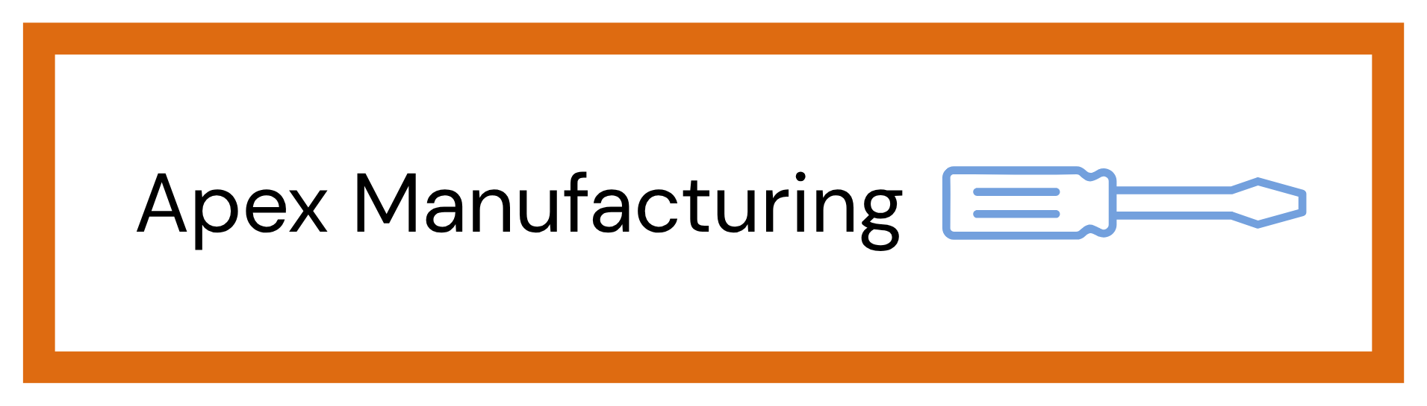 | 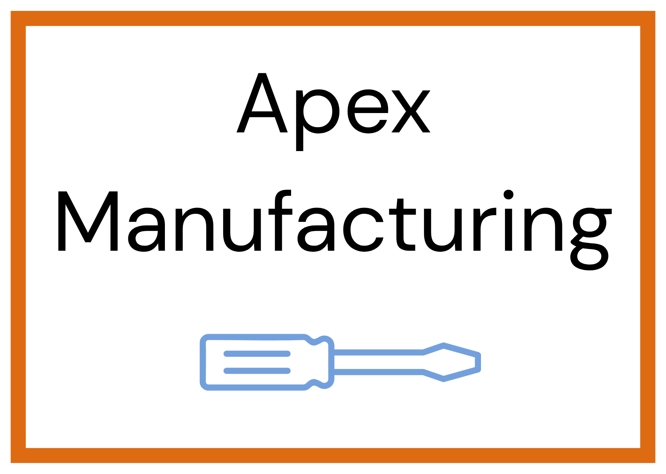 | 
Primary horizontal logo | Stacked logo | Screwdriver mark

Logo rules
Primary logo
Identify the default logo and where it should be used.
The horizontal Apex Manufacturing wordmark with the screwdriver to the right is the default logo under standard brand-use best practices. Use it whenever the available space comfortably supports the full horizontal lockup.
Alternate logo formats
Describe approved monochrome, reversed, horizontal, stacked, or icon-only formats.
The stacked Apex Manufacturing logo is approved for centered, square, or vertical layouts. The standalone screwdriver mark is approved as a supporting icon when the full company name is already visible nearby or context clearly identifies the organization. No monochrome, reversed, SVG, EPS, or other alternate versions were supplied; do not invent them.
Clear space and minimum size
State exact measurements for print and digital use.
Standard clear space: maintain empty space on all sides equal to at least 25% of the total logo height. Minimum recommended size for legibility: horizontal logo 240 px wide digitally or 2.0 in. wide in print; stacked logo 180 px wide digitally or 1.5 in. wide in print; screwdriver mark 48 px wide digitally or 0.5 in. wide in print. If the company name becomes difficult to read, use a larger size rather than reducing spacing.
Prohibited treatments
List changes that are not allowed, including stretching, recoloring, rotating, cropping, or adding effects.
Do not stretch, compress, rotate, skew, crop, recolor, outline, redraw, add shadows or effects, alter proportions, change the typeface, rearrange elements, change border weight, place other graphics inside the clear-space area, or recreate the logo from text and shapes. Use the supplied artwork as-is. Do not create an unapproved monochrome or reversed version.

Supporting visual assets
Include photography, illustrations, icons, patterns, presentation graphics, and approved templates.
Asset type | Description | Approved use | Restrictions | File location
Brand color palette | Apex Blue #73A0DD and Apex Orange #DE6B11. Black and white are neutral support colors for readable text, backgrounds, and contrast. | Documents, presentations, web graphics, social graphics, tables, accents, calls to action, and branded layouts. | Do not substitute near-match brand colors. Use black text on the brand colors when small-text contrast is required; do not rely on color alone to convey meaning. | Brand Guidelines; color specifications supplied by Apex Manufacturing
Typography | DM Sans is the primary company font. | Headings, body copy, captions, tables, presentations, digital graphics, and branded collateral. | Do not use decorative fonts as the primary brand typeface. A neutral sans serif may be used only as a temporary technical fallback if DM Sans is unavailable. | Brand Guidelines; typography specification supplied by Apex Manufacturing
Photography and imagery guidance | Clean, credible manufacturing imagery with clear subject matter and safe work practices. | Approved marketing and communications materials when imagery accurately represents the intended subject. | No unapproved customer work, confidential information, unsafe practices, or imagery that implies unsupported capabilities. No specific photography library was supplied. | No approved photography library supplied

